Points for the presentation

* Air quality has health, comfort, and productivity impacts
* Particularly for indoor air quality, even though americans spend upwards of 90% of their lives indoors there is little to no regulation of it even though there are indoor pollutant sources that are rarely even monitored
* Existing well known outdoor monitoring systems such as the air quality index provide a VERY rough index of air quality, where it just shows the health concern of the highest pollutant concentrations and does not tell you which type is the issue.  
    
  **Metrics and their effects:**
* CO2 - a proxy for general ventilation effectiveness. Heightened levels can lead to lower productivity discomfort and drowsiness
* VOCs - class respiratory irritants that include known and suspected carcinogens found in building products
* PM - respiratory effects, can lead to development of asthma
* Temperature - simply included because it affects comfort and productivity in conjunction with CO2
* RH - excessively high and low levels have a variety of impacts (see chart)

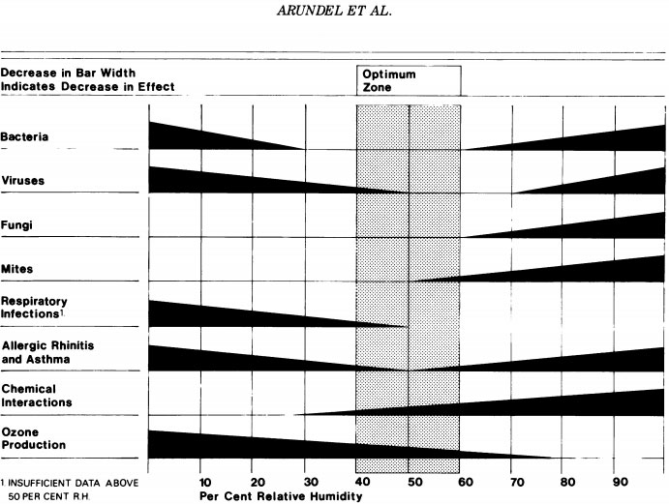

* Existing IAQ monitors are expensive (touch on our system cost) but most importantly, they tend not to be cloud based so a system that is cloud based could link up a bunch of sensors to map out and compare air quality across many spaces
* Ours can provide recommendations **(we need to figure out how to display strings on wallflower though)**
* Real time monitoring and innovative summary stats help convey data to users more effectively. It also allows them to test strategies on their own and see the effect it has on their air quality using this device.

Also we need to do some kind of back of the envelope calculation about the impact of the system. I can look through all the links I saved and work on that.